Leia 6 erinevust.

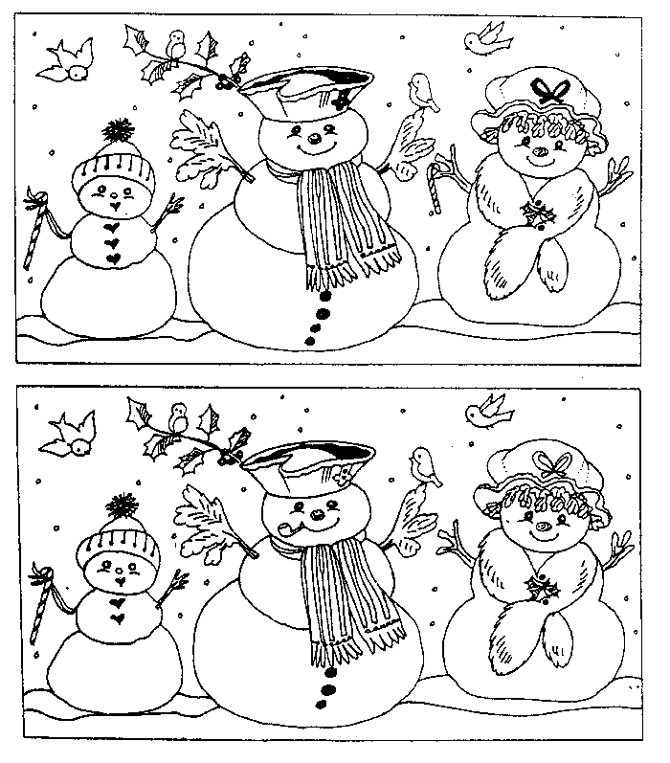
Top of Form

